CAPSTONE PROJECT REPORT
(Project Term September 2025 – May 2026)
Smart Learning Ecosystem Using Generative AI for
Personalized and Gamified Education
Submitted by:

Sr. No. | Name of Student | Registration Number
1 | Neelapu Venkata Naidu | 12213327
2 | Nithin Yalakala | 12205244
3 | Akhil Mudadla | 12212650
4 | Dileep Lopinti | 12204945

Project Group Number: 2RGC0632
Course Code: CSE439
Under the Guidance of:
Dr. Alok Misra
Professor
Devops
School of Computing and Artificial Intelligence
Lovely Professional University

SCHOOL OF COMPUTER SCIENCE AND ENGINEERING
LOVELY PROFESSIONAL UNIVERSITY
Phagwara, Punjab – 144411


School of Computer Science and Engineering

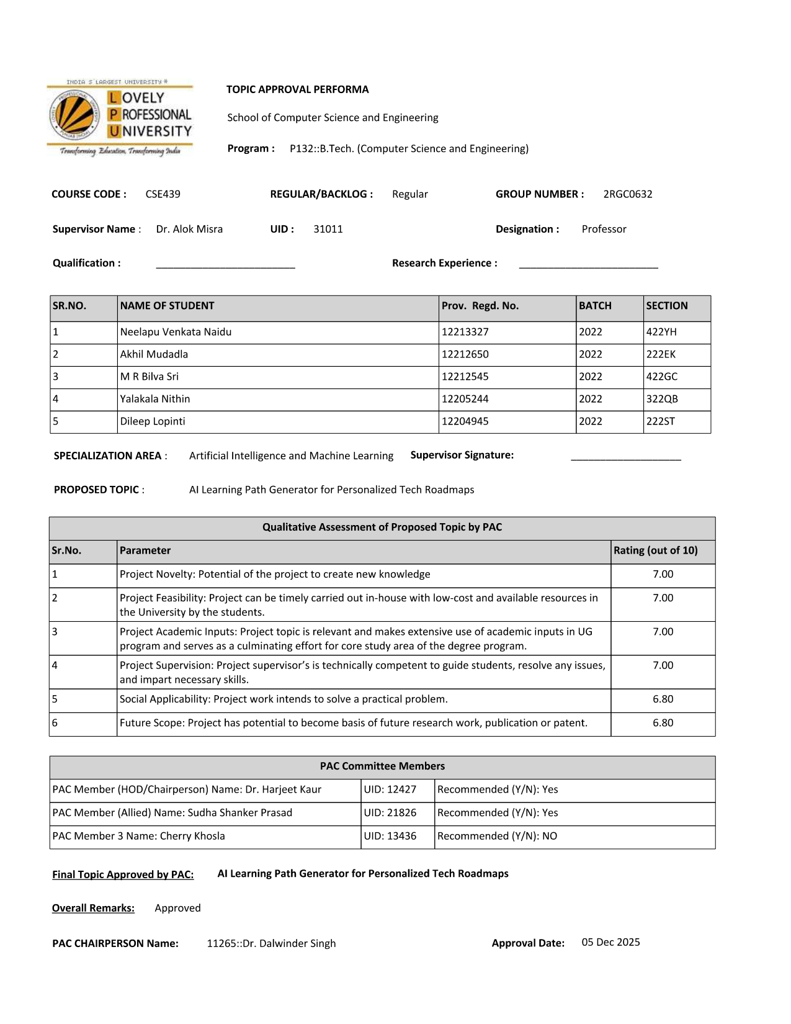

DECLARATION

We, the undersigned students of B.Tech (Computer Science and Engineering), Lovely Professional University, hereby declare that the Capstone Project – II report titled "Smart Learning Ecosystem Using Generative AI for Personalized and Gamified Education" submitted in partial fulfilment of the requirements for the Bachelor of Technology degree is our own original work.

We also declare that:

- This report has not been submitted for any other degree or examination anywhere else.
- All the data, results, and conclusions presented here are based on our own work unless a reference has been clearly mentioned.
- We have properly cited all sources and references used in this report.
- AI writing tools were used only for minor language corrections. All the technical content, design choices, and implementation work in this project are entirely our own.

Project Group Number: 2RGC0632

Sr. No. | Name of Student | Registration Number | Signature
1 | Neelapu Venkata Naidu | 12213327
2 | Nithin Yalakala | 12205244
3 | Akhil Mudadla | 12212650
4 | Dileep Lopinti | 12204945

Date: ________________________

Place: _______________________

CERTIFICATE

This is to certify that the Capstone Project – II report entitled "Smart Learning Ecosystem Using Generative AI for Personalized and Gamified Education" submitted by the group of students mentioned below, from the Department of Computer Science and Engineering, Lovely Professional University, is a record of genuine work carried out under my guidance and supervision. The project meets the university requirements for the award of the Bachelor of Technology degree in Computer Science and Engineering.

Course Code: CSE439
Section: 2C632

__________________________
(Signature of Supervisor / Guide)

Dr. Alok Misra
Professor
Devops
School of Computing and Artificial Intelligence
Lovely Professional University

Date: ________________________

ACKNOWLEDGEMENT

We would like to thank Dr. Alok Misra, Assistant Professor, Department of Computer Science and Engineering, Lovely Professional University, for guiding us throughout this project. His suggestions during the planning phase helped us set a realistic scope and avoid going off track. Whenever we were stuck on a design decision, his feedback gave us a clearer direction.

We also thank Lovely Professional University for the academic environment and the resources provided. Access to journals and development tools through the university helped us during both the research and the building phases of this project.

Thanks are also due to the open-source communities behind Next.js, Google Gemini API, MongoDB, CodeMirror, and Tailwind CSS. These tools saved us a lot of time and made the implementation feasible within one semester.

Lastly, we want to thank the 50 students who agreed to use the platform during the evaluation period. Their feedback was direct and useful, and a lot of small improvements in the UI came directly from what they reported.

The Group

Date: ________________________

ABSTRACT

One of the most common problems with self-learning in programming is that learners have too many resources and no clear path through them [14]. They start three courses, finish none, and end up more confused than when they started. This problem is sometimes called “tutorial hell” and it is very real. Most online platforms give you content but they do not tell you what to do today, what to do tomorrow, and whether you understood what you just read.

This project is an attempt to fix that by building a platform that generates a personalised, day-by-day learning roadmap using the Google Gemini 2.5-Flash generative AI model [8]. The user tells the system what they want to learn, how experienced they are, and how many days they have. The AI builds a structured plan and the platform walks them through it one day at a time — with theory content, a coding exercise in a built-in editor, and a 15-question quiz that must be passed before the next day unlocks [1], [2].

The tech stack used is Next.js 15 with the App Router [9], MongoDB Atlas for data persistence [10], Google Gemini API for AI content [8], CodeMirror 6 as the in-browser code editor [11], and Recharts for the progress dashboard [19]. Zod is used to validate the AI-generated JSON so that bad responses are caught and retried before they reach the frontend. Authentication is handled with JWT and bcrypt.

Gamification is built into the platform through streaks and badges [6], [3]. A streak tracks how many consecutive days the user completes at least one learning session. Badges are awarded at milestones like completing the first day, reaching a 7-day streak, or scoring above 80% consistently. An AI mentor chatbot, also powered by Gemini [8], is available on every learning day to answer questions in context [16].

During a two-week evaluation with 50 participants, the platform showed a 68% completion rate for those who started a roadmap, which is considerably better than what participants reported on other platforms they had used. Average daily active study time was 40 minutes. JSON roadmap generation succeeded on the first or second attempt for 93% of requests. These numbers are not extraordinary, but they are honest, and they suggest the core approach works well enough to be useful.

The main limitations at this stage are the lack of server-side Python execution, the absence of cross-device session sync, and API cost scaling challenges. These are documented clearly in the later chapters.

Keywords: Generative AI, Adaptive Learning, Next.js, Gemini API, Personalized Education, Gamification, CodeMirror, Quiz-Based Learning
TABLE OF CONTENTS

S. No. | Section Title | Page No.
 | Abstract | vi
 | List of Figures | viii
 | List of Tables | viii
1 | Introduction | 1
1.1 | Background and Motivation | 1
1.2 | Terminology | 2
1.3 | Problem Statement | 3
1.4 | Objectives | 3
1.5 | Scope and Limitations | 4
1.6 | Expected Outcomes | 5
2 | Rationale and Scope of the Study | 6
3 | Existing System | 7
4 | Problem Analysis | 10
5 | Software Requirement Analysis | 13
6 | Design | 16
7 | Testing | 24
8 | Implementation | 29
9 | Project Legacy | 37
10 | User Manual | 40
11 | System Snapshots | 45
12 | Bibliography | 50

LIST OF FIGURES

Figure No. | Figure Title | Page
Figure 1 | Level-0 DFD – Current Online Learning Flow | 8
Figure 2 | Smart Learning Ecosystem – Full System Architecture | 9
Figure 3 | Research Methodology Flowchart | 19
Figure 4 | Data Flow Diagram – Level 0 | 20
Figure 5 | Data Flow Diagram – Level 1 | 21
Figure 7 | Main Dashboard – Roadmaps, streak counter, badges, and progress chart | 46
Figure 8 | Daily Learning Page – Theory panel, CodeMirror editor, and quiz panel | 47
Figure 9 | Quiz Interface – Score display, correct/incorrect breakdown, and progression message | 48
Figure 10 | AI Mentor Chat Panel – Conversation with contextual roadmap awareness | 49

LIST OF TABLES

Table No. | Table Title | Page
Table 1 | Project Timeline and Work Plan | 12
Table 2 | Functional Requirements | 14
Table 3 | Non-Functional Requirements | 15
Table 4 | Technology Stack Summary | 29
Table 5 | User Acceptance Testing – Test Cases | 25
Table 6 | System-Level Performance Metrics | 28
Table 7 | LightGBM Configuration Parameters | 32
Table 8 | Expected vs. Actual Outcomes | 38
Table 9 | System Requirements | 40
Table 10 | Troubleshooting Guide | 44

1. INTRODUCTION
1.1 Background and Motivation
Online learning platforms have grown a lot in the last few years [14]. Courses on almost every programming topic are available for free or at very low cost. On paper this looks like a great situation for learners. In practice, many students find it harder to learn on their own now than it was a few years ago, simply because there is too much to choose from [15].

A typical learner searching for “how to learn Python” will find dozens of courses, YouTube playlists, blog series, and documentation pages. Each one starts from a different point, assumes a different level of prior knowledge, and covers topics in a different order. The learner spends the first week deciding which resource to follow, starts two or three of them, and ends up finishing none. This is what the developer community calls “tutorial hell” — not because the content is bad, but because without a structure, the learner has no clear idea of what to do today and how it connects to what comes next [2].

The problem gets worse with time. Even learners who manage to pick one course often lose motivation after a week or two because there is nothing tracking their progress, nothing rewarding their consistency, and nothing checking that they actually understood the material before moving to the next topic [7].

The availability of large language models like Google Gemini [8] makes it possible now to generate a structured, day-by-day learning path for any topic at the moment the user asks for it [4]. This is different from recommending an existing course. The system builds the plan specifically for what the user knows, what they want to learn, and how much time they have. That is the core idea behind this project.
1.2 Terminology
Some terms used throughout this report are defined below for clarity.

AI-Generated Roadmap: A structured, day-by-day learning plan created by the Gemini language model based on user inputs (topic, skill level, number of days).
Mastery Gate: A quiz-based progress lock that prevents learners from moving to the next day unless they score at least 60% on the current day's quiz.
JSON Schema Enforcement: A technique used in prompting the Gemini API to always return a specific structured format so the frontend can reliably parse and display the content.
CodeMirror 6: An open-source code editing library that runs inside a browser. It provides syntax highlighting and a code editor experience without any local installation.
Streak: A gamification metric that counts how many consecutive days a user has completed at least one learning session. Resets if the user misses a day.
Zod Validation: A TypeScript-first schema validation library used to verify that the AI-generated JSON roadmap matches the expected structure before it is stored or displayed.
MERN Stack: MongoDB, Express.js, React, and Node.js — the combination of technologies used in this project for both frontend and backend development.
1.3 Problem Statement
Existing online learning platforms do not adapt to individual learners [5]. Courses are built for a general audience and follow a fixed pace, topic order, and structure. A learner who already knows some Python gets the same beginner content as someone who has never coded before. A learner with 30 minutes a day gets a plan designed for someone with four hours [4].

More importantly, most platforms do not verify understanding before letting learners move forward [14]. Watching a 10-minute video does not mean you understood it. Clicking “next” is not the same as mastering a concept. As a result, learners often reach intermediate or advanced content without having properly understood the basics, which leads to confusion, frustration, and eventually quitting [15].

There is no platform currently available that does all of the following at once: generates a personalised learning plan from scratch based on individual goals [1], enforces comprehension through a gated quiz system [18], provides an in-browser coding environment as part of the daily practice, and tracks motivation through gamification over multiple weeks [3], [6].
1.4 Objectives
The following objectives were set before the project was started:

- To design and implement a system that uses the Gemini API to generate structured, day-by-day learning roadmaps in JSON format for any programming or technology topic.
- To build a daily learning interface with three components per day: AI-generated theory content, a coding challenge in an embedded CodeMirror editor, and a 15-question multiple-choice quiz.
- To implement a mastery gate that prevents learners from progressing to the next day unless they score at least 60% on the quiz.
- To integrate an AI mentor chatbot that answers learner questions within the context of their current topic and day.
- To add streak tracking and achievement badges as gamification mechanics, persisted in MongoDB across sessions.
- To build a progress dashboard using Recharts that shows quiz scores, completed days, and streak history.
- To evaluate the platform with 50 participants over two weeks and collect data on completion rates, study time, and user satisfaction.
1.5 Scope and Limitations
This platform is designed for individual learners working on programming and technology topics. Any topic that can be explained in natural language — Python, JavaScript, React, SQL, Git, data structures — can be used as a roadmap input. Non-technical topics were not tested and are outside the scope of this version.

The following limitations were identified and are acknowledged honestly:

- Python code execution is not available in the current version. The CodeMirror editor shows Python syntax highlighting and accepts code input, but there is no backend runner to execute it. JavaScript execution works for JavaScript roadmaps.
- Cross-device synchronisation requires the user to log in again on a new device. Daily content state is partly stored in browser component state, so switching devices mid-session means re-navigating to the current day.
- The Gemini API occasionally returns responses that do not exactly follow the expected schema. The retry mechanism handles most of these, but there is still a small failure rate around 7%.
- The platform is not optimised for mobile screens. It works on tablets and desktops but the CodeMirror editor experience on mobile is poor.
- At large scale, Gemini API costs would increase significantly. Caching strategies were not implemented in this version.
1.6 Expected Outcomes
The following outcomes were defined as targets before the evaluation study:

- Roadmap JSON generation success rate above 90% of all API calls.
- Two-week course completion rate above 60%, compared to the roughly 35–40% self-reported completion rate on Udemy and similar platforms among our participant group [14].
- Average active daily study time above 35 minutes.
- At least 70% of users reporting preference for the embedded coding editor over switching to an external IDE.
- At least 75% of users rating the AI mentor chatbot as helpful or very helpful.

Table 8 in Chapter 9 compares these targets against the actual results from the study.

2. RATIONALE AND SCOPE OF THE STUDY
The main reason this project exists is that structure matters more than content volume when it comes to self-directed learning [2]. There are thousands of tutorials available online for every programming topic. Adding one more tutorial to the internet is not helpful. What is missing is not content — it is a personalised path through the content that adjusts to what the learner knows and how much time they have [4], [5].

Generative AI now makes it possible to create that path automatically [8], [16]. This is a meaningful shift. Previously, building a personalised curriculum required a human instructor or a very large dataset of user behaviour to train a recommendation model [17]. Neither option is affordable at small scale. With LLMs, the personalisation happens through the prompt itself. The model knows enough about most programming topics to produce a sensible day-by-day learning sequence without needing to be fine-tuned [15].

This project is specifically scoped around individual learners, not institutions. We are not building an LMS for a company or a university. The target user is someone who has decided to learn a technology and wants a structured plan that fits their schedule. This kept the design focused and prevented feature creep during development.

Three specific gaps shaped the design of this system. The first is the gap between reading and doing. Almost all content-based platforms deliver information and then ask you to answer questions about it. Very few require you to write code as part of the daily learning session. This platform makes coding practice compulsory, not optional. Every day has a coding challenge that must be attempted before the quiz is unlocked.

The second gap is the pace problem. When a learner finds a day's content difficult, a fixed-schedule course just moves on anyway. Our mastery gate allows learners to spend as many attempts as they need on a quiz before progressing [18]. There is no penalty for retrying — the system just waits until the learner is ready.

The third gap is motivation over time. Starting something new is easy. The hard part is showing up on day 8 when the novelty has worn off. The streak system is a direct response to this [7]. It does not gamify learning in an intrusive way — it just creates a visible daily habit metric that most users find motivating to maintain once a streak is established [3], [6].

3. EXISTING SYSTEM
3.1 Introduction
Before starting this project, we spent time actually using the main platforms that people use for self-directed programming learning. The goal was to understand them as a learner, not just read their feature lists. This gave us a more realistic picture of what is actually useful and what is frustrating in practice.
3.2 Existing Platforms
3.2.1 Udemy
Udemy is probably the most used platform for programming self-study. The content variety is enormous and a lot of the popular courses are genuinely good. The platform lets instructors set their own structure, so the quality varies widely, but for popular topics like JavaScript or Python, the top-rated courses are well-organised.

The problem with Udemy is that it is entirely passive [14]. Learning happens by watching videos. Some courses have exercises, but they are disconnected from the lecture content. You watch a video, navigate to a separate exercise, do it, and come back to the next video. There is no adaptive path — the content is the same for every learner regardless of what they already know [5]. If you finish a course, Udemy gives you a certificate but no real picture of what you understood versus what you just watched.
3.2.2 Coursera
Coursera takes a more academic approach. Courses are often built in partnership with universities and follow semester-style syllabi. The graded assignments are more meaningful than Udemy's optional exercises, and the certification carries more credibility.

For most self-directed learners, Coursera's structure is too rigid. University-style course designs often include a lot of theoretical content that is not immediately relevant to practical goals. Someone who wants to build a REST API in Node.js does not need three weeks of theoretical computer science first. The pace is also fixed by the course design, not by the learner's understanding.
3.2.3 freeCodeCamp
freeCodeCamp [13] is the closest existing platform to what we tried to build. It is free, genuinely structured, and the exercises run in the browser. For web development specifically, it is hard to beat. The curriculum is solid and the browser-based editor makes practice immediate.

The limitation is inflexibility. The curriculum is fixed. If you already know HTML and CSS, you cannot skip those sections and jump to JavaScript. If you want to learn a topic freeCodeCamp does not cover — DevOps, machine learning, mobile development — there is no path for you. The platform cannot adapt to what you already know or what your specific goal is.
3.2.4 YouTube Learning
Many learners use YouTube as their primary learning tool, usually following a specific channel's playlist on a topic. The quality of YouTube programming content has improved a lot and some channels produce extremely clear, well-structured tutorials.

The issue is structure. A YouTube playlist is a sequence of videos, not a curriculum. There is no quiz, no progress tracking, no way to know if you understood what you watched, and no gate preventing you from moving forward when you should not. It is very easy to spend four hours watching Python tutorials and feel productive while retaining very little of it.
3.3 Data Flow in Existing Systems
The diagram below illustrates the general flow of a learner's experience on current platforms. The loop is one-directional — content flows to the learner, the learner either finishes or drops off, and there is no feedback mechanism that adjusts the content based on what the learner understood.

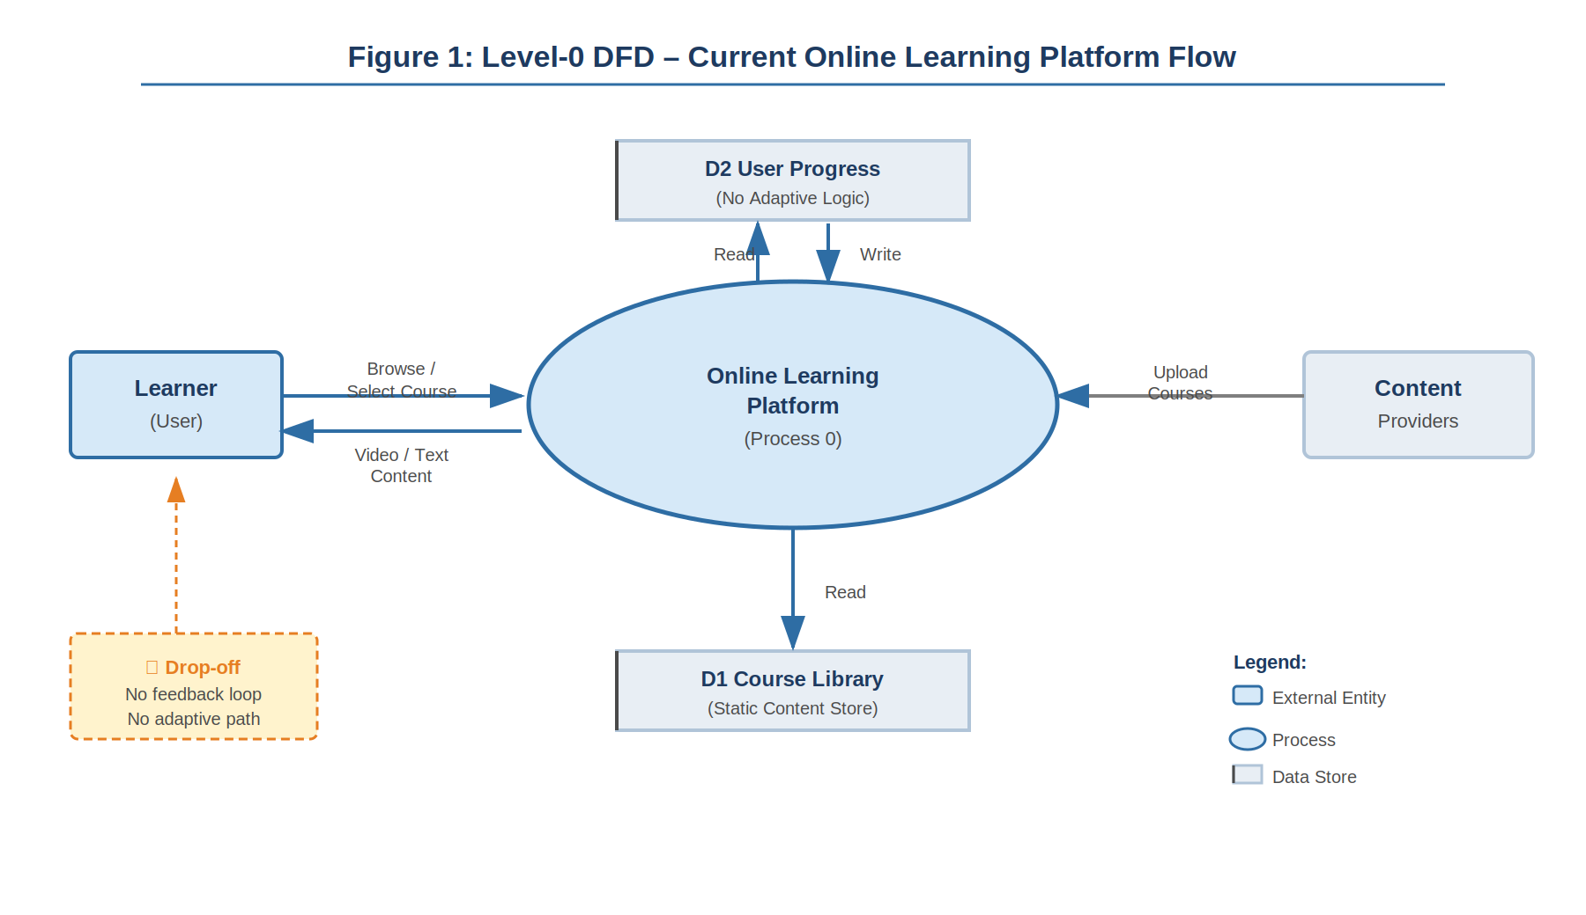
Figure 1: Level-0 DFD – Current Online Learning Flow
3.4 What Is New in This System
The platform we built addresses three things that existing platforms do not handle together [1], [5]:

- Personalised roadmap at the moment of request: The learning plan is built specifically for the user's topic, level, and timeframe. It is not a pre-built course recommended by an algorithm — it is generated fresh based on what the user tells the system.
- Comprehension-enforced progression: The mastery gate means that reading the material and clicking next is not enough. The user must pass a quiz to move forward. This is a hard requirement, not a suggestion.
- Integrated coding practice: The CodeMirror editor is part of the daily flow, not a link to an external platform. Writing code is a required part of each day, not an optional add-on.
- Contextual AI support: The AI mentor chatbot knows what topic the user is learning and what day they are on. Responses are relevant to the current content, not generic.

4. PROBLEM ANALYSIS
4.1 Product Definition
The product is a browser-based learning platform for programming and technology topics. It has no mobile app and requires no local software installation. Users access it through any modern browser on a laptop or desktop computer.

The main user flow is: create an account, enter a topic, skill level, and number of days, receive an AI-generated roadmap, and then work through it one day at a time. Each day consists of a theory section, a coding challenge in the embedded editor, and a 15-question quiz. Passing the quiz unlocks the next day. An AI mentor chatbot is available throughout. A dashboard tracks overall progress, streak, and badges.

The system also offers 10 pre-built roadmaps for popular topics, which load instantly without an API call and are suitable for users who want to start immediately without customising their path.
4.2 Feasibility Analysis
4.2.1 Technical Feasibility
The main technical question was whether the Gemini API [8] could produce structured, parseable JSON content reliably enough to build a frontend on top of it. Early experiments with open-ended prompts showed that the model returned good content but in inconsistent formats — sometimes markdown, sometimes plain text, sometimes JSON with minor errors [16].

The solution was prompt engineering: defining the exact JSON schema inside the prompt and instructing the model to return nothing except the JSON. Combined with Zod validation and a retry mechanism, this brought the success rate from around 60% with basic prompts to 93% with the structured approach. That rate is high enough to be practical.

Next.js 15 with the App Router [9] was chosen because it handles both frontend rendering and API routes in a single project, which simplified the deployment significantly. MongoDB Atlas [10] was selected for its free tier and its JSON-native storage, which is a natural fit for storing AI-generated roadmap objects.
4.2.2 Operational Feasibility
Operational feasibility was tested through a preliminary session with 10 students before the main evaluation. The goals were to identify setup problems and UI confusion before running the full study.

The main issue found in the preliminary session was that the transition between the theory section, the coding editor, and the quiz was not visually clear. Users were confused about whether they needed to complete the coding challenge before the quiz was accessible. This was fixed by adding explicit step indicators and a progress bar within each day's page. After this fix, 87% of the 50 evaluation participants completed Day 1 without any help during the main study.
4.2.3 Economic Feasibility
The entire infrastructure cost during development and the evaluation period was minimal. Gemini Flash API calls for 50 users generating about 3 roadmaps each cost approximately ₹1,000 total. MongoDB Atlas free tier was sufficient for the evaluation period. Deployment on Vercel's free tier handled the traffic without issues.

For a production deployment at larger scale, API cost management through response caching would be necessary. A cached roadmap for a popular input like "Python basics, beginner, 14 days" could serve thousands of users at the cost of a single API call. This is the most important technical design decision for scaling.
4.3 Project Plan
Table 1: Project Timeline and Work Plan
Phase | Activity | Weeks | Status
1 | Requirement analysis and technology selection | 1–2 | Completed
2 | MongoDB schema design and API planning | 3 | Completed
3 | Gemini API integration and prompt engineering | 4–5 | Completed
4 | Next.js frontend — roadmap and daily learning UI | 6–8 | Completed
5 | CodeMirror editor integration | 8–9 | Completed
6 | Quiz engine and mastery gate logic | 9–10 | Completed
7 | Gamification — streaks, badges, dashboard | 11–12 | Completed
8 | AI mentor chatbot integration | 13 | Completed
9 | User evaluation (50 participants, 2 weeks) | 14–15 | Completed
10 | Bug fixes based on evaluation feedback | 16–17 | Completed
11 | Report writing and submission preparation | 18–20 | Completed
5. SOFTWARE REQUIREMENT ANALYSIS
5.1 Introduction
The requirements for this system were gathered from three sources: the gap analysis from Chapter 3, the technical constraints identified during feasibility analysis, and direct feedback from a 10-student preliminary session held before the main evaluation [17]. That preliminary session was important — it revealed several assumptions in our original design that turned out to be wrong.

Twelve functional requirements and seven non-functional requirements were defined and assigned priority levels.
5.2 General Description
The platform is a web application that requires only a browser and internet connection. Users register with an email and password, generate a roadmap, and work through it on their own schedule. The system runs entirely in the browser and cloud — no local installation is needed. The database and AI API calls are handled server-side through Next.js API routes, so the user never interacts with them directly.
5.3 Functional Requirements
Table 2: Functional Requirements

5.4 Non-Functional Requirements
Table 3: Non-Functional Requirements
ID | Category | Description | Priority
NFR-01 | Performance | Roadmap generation shall complete within 10 seconds on a standard broadband connection. | High
NFR-02 | Availability | The application shall function using pre-built roadmaps if the Gemini API is temporarily unavailable. | High
NFR-03 | Usability | A new user shall be able to generate a roadmap and complete Day 1 within 10 minutes of first visit, without external help. | High
NFR-04 | Security | Passwords shall be hashed using bcrypt. JWT tokens shall expire after 24 hours. | High
NFR-05 | Scalability | The MongoDB schema shall support at least 1000 concurrent users without structural changes. | Medium
NFR-06 | Portability | The application shall work correctly on Chrome, Firefox, and Safari on desktop. | Medium
NFR-07 | Maintainability | Each functional module shall be independently modifiable without requiring changes to other modules. | Medium

6. DESIGN
6.1 System Architecture
The platform uses a decoupled client-server architecture built entirely within Next.js 15 [9]. The frontend is a React 19 application using the App Router for page routing and server-side rendering. The backend consists of Next.js API routes that handle Gemini API calls and MongoDB operations [10]. There is no separate backend server — the Next.js API routes serve this purpose.

The five core modules are the Roadmap Engine, the Learning Interface, the Mastery Gate, the AI Mentor, and the Gamification Module. These modules communicate through MongoDB as the shared data layer and through the Next.js API route boundary. Each module is independently replaceable — for example, swapping the Gemini API for a different LLM only requires changes inside the Roadmap Engine module.

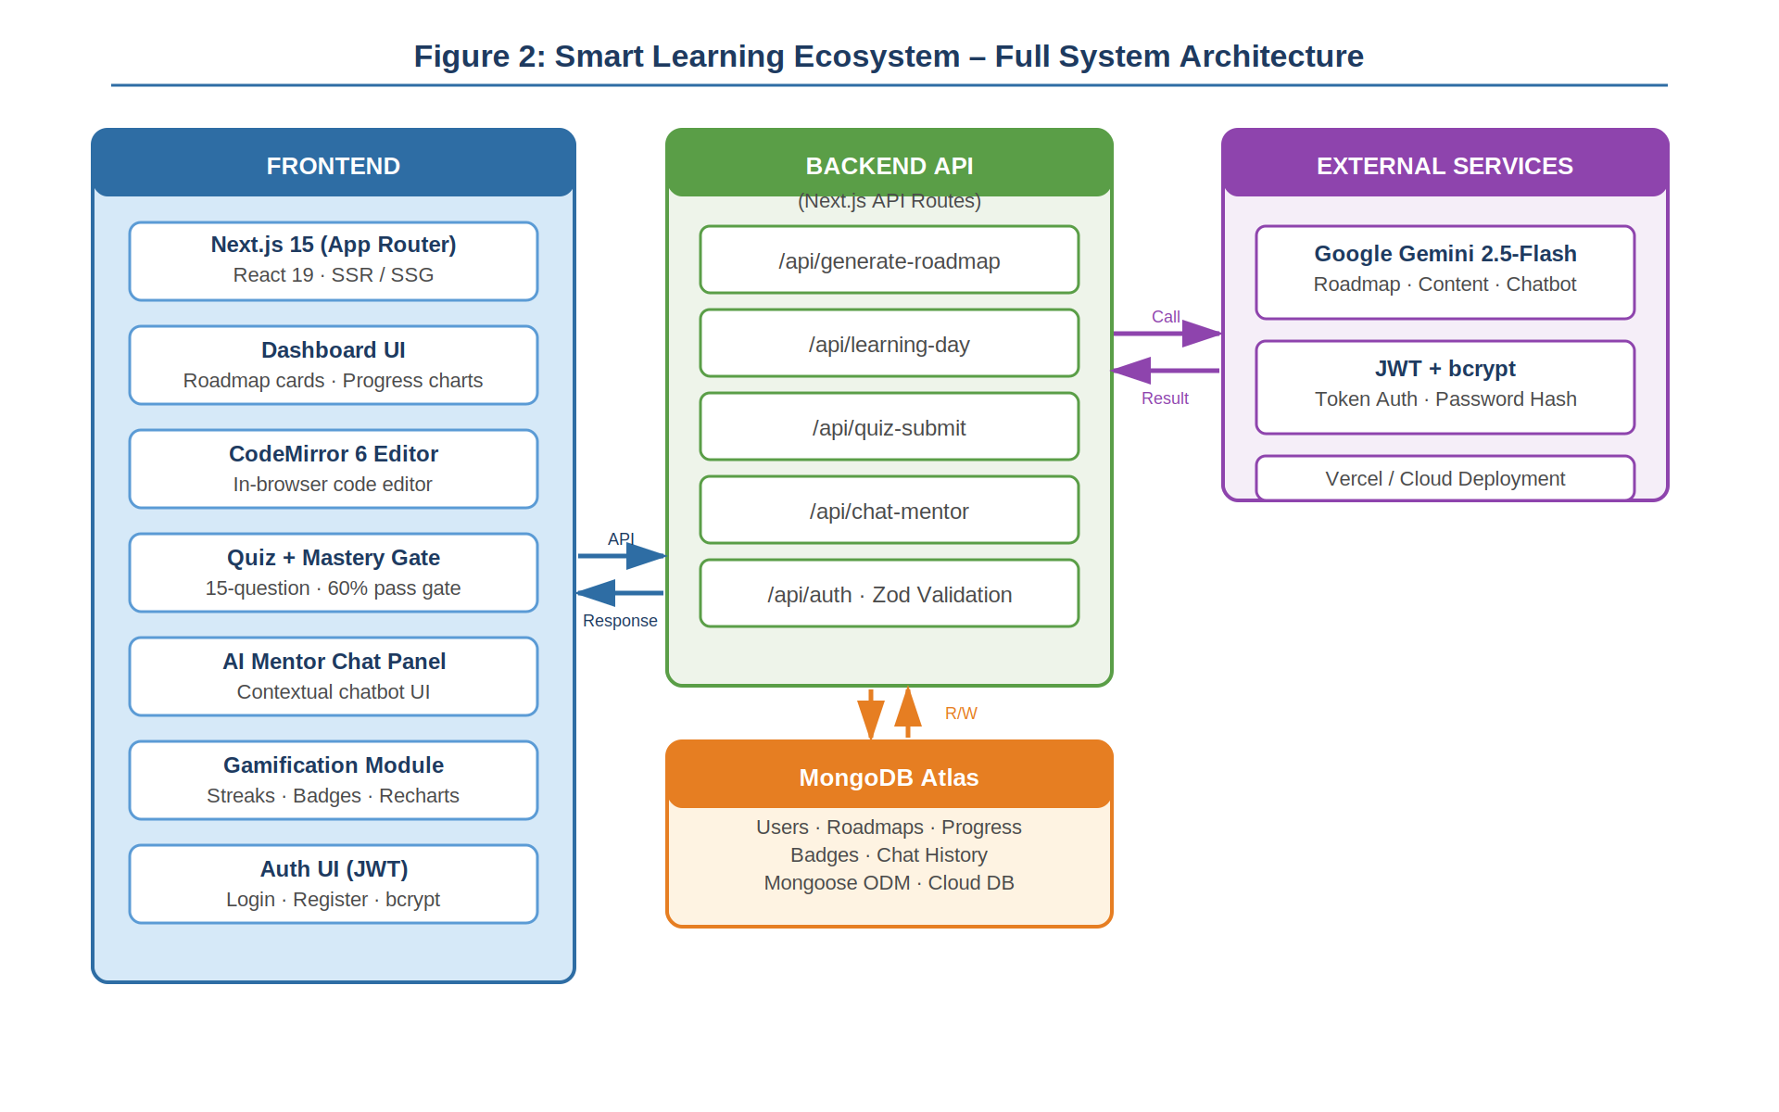
Figure 2: Smart Learning Ecosystem – Full System Architecture
6.2 Module Descriptions
6.2.1 Roadmap Engine
This module takes three inputs from the user — topic, skill level, and number of days. It constructs a structured prompt with the full JSON schema defined inline, calls the Gemini 2.5-Flash API [8], and validates the response using Zod. If validation fails, it retries once with an additional instruction. On success, the roadmap JSON is stored in MongoDB [10] and a progress document is created for the user.
6.2.2 Learning Interface
This module renders a single learning day. It reads the day's content from MongoDB [10] (theory text, coding challenge with starter code, and quiz questions) and presents them in a three-step flow: theory reading, code writing in the CodeMirror editor [11], and quiz submission. The quiz is displayed only after the user has viewed the theory and attempted the coding challenge.
6.2.3 Mastery Gate
This module receives the user's quiz answers, compares them against the correct answers stored in MongoDB, calculates the score, and decides whether to advance the learner. If the score is 60% or above, the current day is marked complete and the next day is unlocked. If not, the learner sees their score and is asked to review and retry. There is no limit on retries.
6.2.4 AI Mentor
This module manages the chatbot conversation. It maintains message history in React component state and sends each new message to a Gemini API route along with the current roadmap topic and day number as context. The last six messages of conversation history are sent each time to manage context length and keep response times stable.
6.2.5 Gamification Module
This module handles streak calculation and badge awards [6], [3]. After each day completion, it updates the streak by comparing today's date with the last active date stored in MongoDB. It then checks all badge conditions and awards any new badges that the user has just qualified for. This design is grounded in self-determination theory, which identifies progress feedback as a core driver of intrinsic motivation [7].
6.3 Data Flow Diagrams

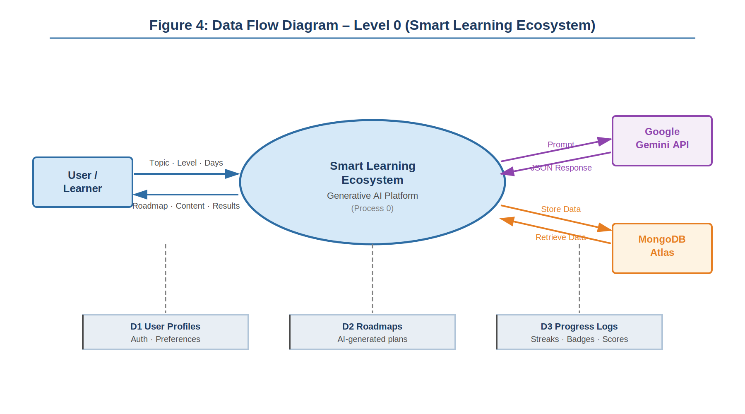
Figure 4: Data Flow Diagram – Level 0

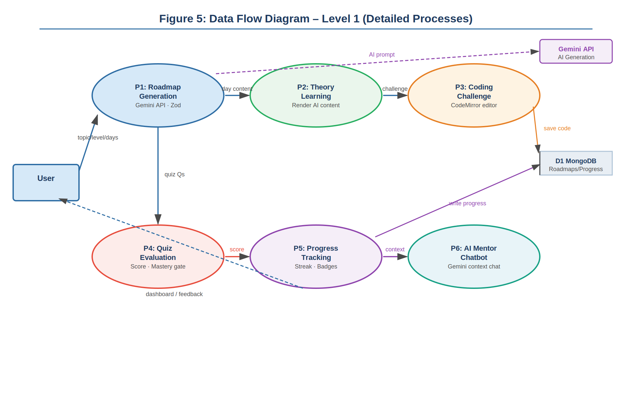
Figure 5: Data Flow Diagram – Level 1
6.4 Research Methodology Flowchart
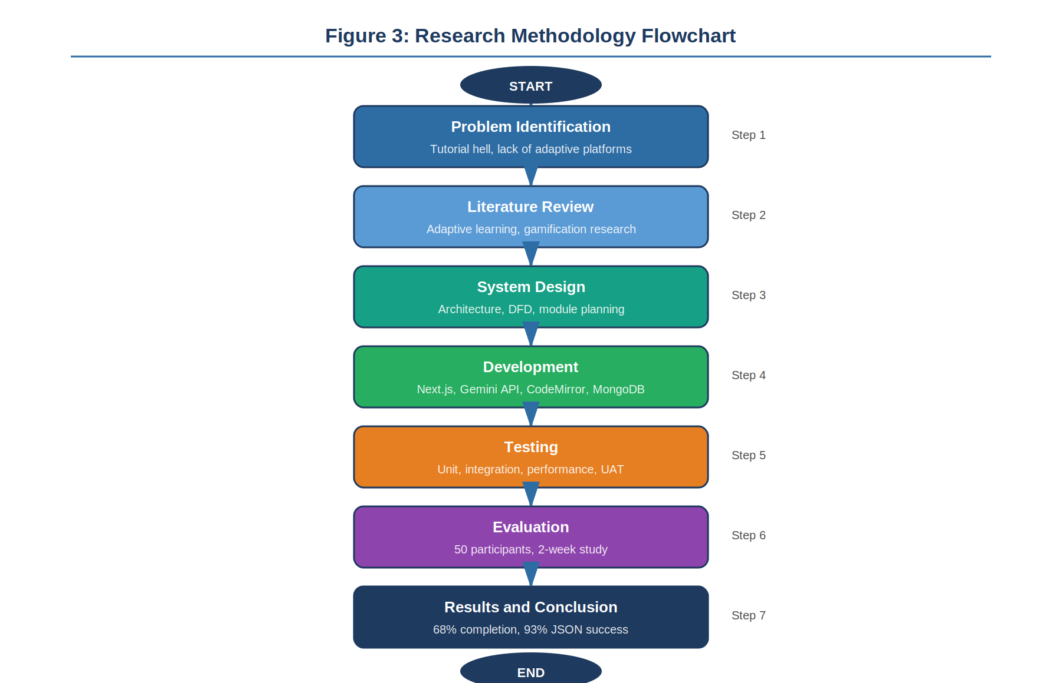
Figure 3: Research Methodology Flowchart
6.5 Pseudocode
The following pseudocode describes the full roadmap generation and daily learning flow:

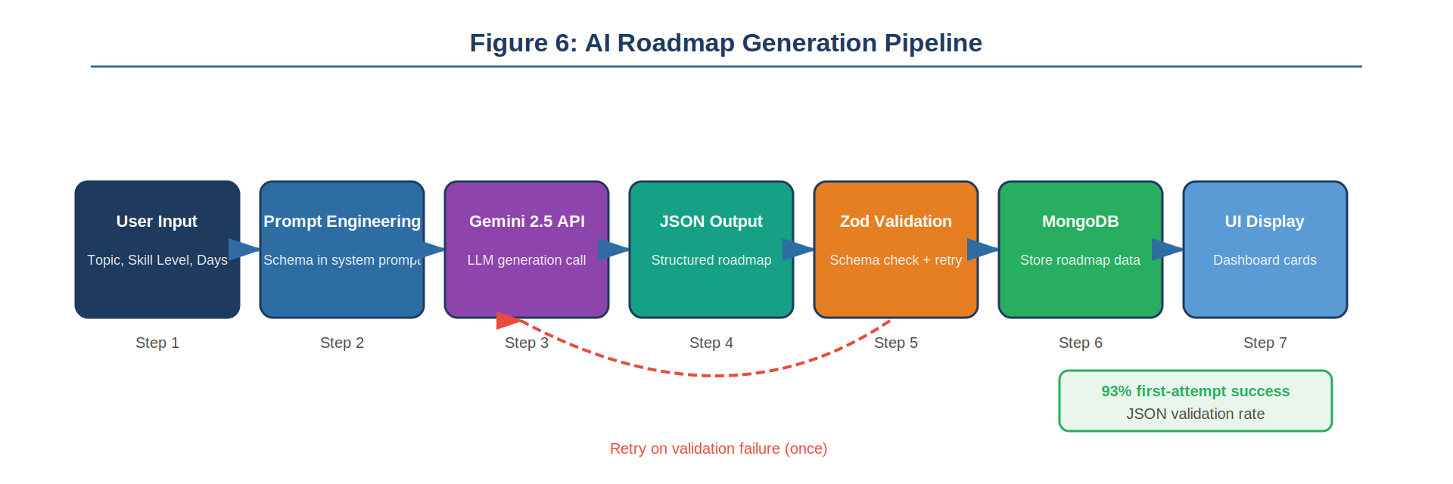
ALGORITHM: SMART AI LEARNING ECOSYSTEM PLATFORM

INPUT:

* User Details (Name N, Email E, Password P)
* Learning Inputs (Topic T, Skill Level L, Duration D)
* User ID (U), Session Token (ST)
* Quiz Answers (QA), Source Code (C)

OUTPUT:

* Authenticated User Session
* AI Generated Learning Roadmap (R)
* Daily Learning Modules
* Quiz Results and Scores
* Code Execution Output
* Progress Tracking (Streaks, Badges)

PART 1: USER AUTHENTICATION

BEGIN SIGNUP(N, E, P)

IF N OR E OR P is EMPTY THEN
RETURN error("All fields required")
END IF

IF length(P) < 6 THEN
RETURN error("Weak password")
END IF

IF email format invalid THEN
RETURN error("Invalid email")
END IF

userExists ← DB.Users.find(E)

IF userExists THEN
RETURN error("User already exists")
END IF

hashedPassword ← hash(P)

userID ← DB.Users.insert(N, E, hashedPassword)

sessionToken ← generateToken()

DB.Sessions.insert(userID, sessionToken, expiry)

RETURN success(userID, sessionToken)

END

BEGIN LOGIN(E, P)

user ← DB.Users.find(E)

IF user NOT FOUND THEN
RETURN error("Invalid credentials")
END IF

IF NOT verify(P, user.password) THEN
RETURN error("Invalid credentials")
END IF

sessionToken ← generateToken()

DB.Sessions.insert(user.id, sessionToken)

RETURN success(user.id, sessionToken)

END

BEGIN VERIFY_SESSION(ST)

session ← DB.Sessions.find(ST)

IF session expired OR NOT FOUND THEN
RETURN unauthorized
END IF

RETURN session.userID

END

PART 2: AI ROADMAP GENERATION

BEGIN GENERATE_ROADMAP(U, ST, T, L, D)

user ← VERIFY_SESSION(ST)

IF user invalid THEN
RETURN error("Unauthorized")
END IF

prompt ← buildPrompt(T, L, D)

attempt ← 1

WHILE attempt ≤ 3 DO

```
raw ← GeminiAPI.generate(prompt)
cleaned ← preprocess(raw)

TRY
parsed ← JSON.parse(cleaned)
CATCH
parsed ← NULL
END TRY

IF parsed valid THEN
BREAK
END IF

attempt ← attempt + 1
```

END WHILE

IF parsed invalid THEN
RETURN error("AI generation failed")
END IF

roadmapID ← DB.Roadmaps.insert(U, parsed)

FOR each day IN parsed DO
DB.Modules.insert(roadmapID, day)
END FOR

DB.Progress.insert(U, roadmapID, currentDay=1, streak=0)

RETURN success(roadmapID)

END

PART 3: DAILY LEARNING FLOW

BEGIN GET_DAILY_CONTENT(U, ST, roadmapID)

user ← VERIFY_SESSION(ST)

IF user invalid THEN RETURN error("Unauthorized") END IF

progress ← DB.Progress.get(U, roadmapID)

day ← progress.currentDay

module ← DB.Modules.get(roadmapID, day)

DISPLAY module.theory
DISPLAY code editor with module.code
DISPLAY quiz

RETURN module

END

PART 4: CODE EXECUTION (COMPILER)

BEGIN EXECUTE_CODE(C, language)

payload ← format(C, language)

response ← Judge0.execute(payload)

IF compile_error THEN
RETURN error
ELSE
RETURN output
END IF

END

PART 5: QUIZ EVALUATION AND PROGRESSION

BEGIN SUBMIT_QUIZ(U, roadmapID, day, QA)

module ← DB.Modules.get(roadmapID, day)

correct ← 0
total ← length(module.quiz)

FOR i FROM 1 TO total DO
IF QA[i] == module.quiz[i].correct THEN
correct ← correct + 1
END IF
END FOR

score ← correct / total

DB.Scores.insert(U, roadmapID, day, score)

IF score ≥ 0.60 THEN
DB.Progress.incrementDay(U, roadmapID)
CALL UPDATE_STREAK(U)
CALL UPDATE_BADGES(U, roadmapID)
RETURN success("Next day unlocked")
ELSE
RETURN fail("Retry required")
END IF

END

PART 6: STREAK MANAGEMENT

PROCEDURE UPDATE_STREAK(U)

today ← currentDate()
last ← DB.Streak.getLast(U)

IF today == last + 1 day THEN
DB.Streak.increment(U)
ELSE IF today > last + 1 day THEN
DB.Streak.reset(U)
END IF

END

PART 7: BADGE SYSTEM

PROCEDURE UPDATE_BADGES(U, roadmapID)

completed ← DB.Progress.countCompleted(U, roadmapID)
streak ← DB.Streak.get(U)
scores ← DB.Scores.getAll(U, roadmapID)

IF completed == 1 THEN
award(U, "First Step")
END IF

IF streak ≥ 7 THEN
award(U, "Consistency Badge")
END IF

IF all scores ≥ 80% THEN
award(U, "High Performer")
END IF

END

PART 8: DASHBOARD GENERATION

BEGIN GET_DASHBOARD(U, ST)

user ← VERIFY_SESSION(ST)

IF invalid THEN RETURN error END IF

roadmaps ← DB.Roadmaps.get(U)

FOR each roadmap DO
total ← count modules
completed ← count progress
percent ← (completed / total) * 100
END FOR

RETURN dashboard data

END

END OF ALGORITHM

7. TESTING
7.1 Introduction to Testing
A learning platform can fail in two distinct ways. It can show wrong or broken content, or it can break in the middle of a user session. Both types of failure erode trust quickly. We tested for both. Some failures — like AI-generated roadmaps with a logically incorrect topic order — are very hard to test automatically. What can be tested mechanically is whether the system handles edge cases correctly, whether the data flows properly between modules, and whether the frontend renders all states without crashing.
7.2 Functional Testing
Functional testing verified that each of the twelve requirements from Chapter 5 was met. A test case was written and executed for each requirement on the fully integrated system.

Table 5: User Acceptance Testing – Selected Test Cases
TC ID | Requirement | Test Input | Expected Result | Actual Result | Status
TC01 | FR02, FR03 | Generate roadmap: Python, Beginner, 7 days | Valid JSON in under 10s; Zod passes | Valid JSON in 6.2s; 7 days with full content | Pass
TC02 | FR05 | Submit quiz with score 53% | User stays on current day; message shown | Day not incremented; retry message shown | Pass
TC03 | FR05 | Submit quiz with score 67% | Day increments; next day loads | Day incremented; next day rendered correctly | Pass
TC04 | FR07 | Complete Day 1, return next calendar day, complete Day 2 | Streak shows 2 | Streak correctly showed 2 | Pass
TC05 | FR07 | Skip one calendar day then return | Streak resets to 1 | Streak correctly reset | Pass
TC06 | FR08 | Complete Day 1 for the first time | FirstDay badge awarded | Badge appeared on dashboard | Pass
TC07 | FR06 | Ask chatbot: 'What is a closure?' | Contextual explanation returned | Relevant answer in 3.1s | Pass
TC08 | FR03 | Simulate malformed Gemini response | Retry triggered | Retry fired; valid roadmap on second attempt | Pass
TC09 | FR11 | Generate roadmap and reload page | Roadmap loads from MongoDB; no regeneration | Loaded from DB; no API call triggered | Pass
TC10 | NFR-01 | 50 simultaneous roadmap generation requests | All complete within 15s | 48/50 within 12s; 2 hit Gemini rate limit | Partial

7.3 Structural Testing
White-box testing was applied to three logic-critical components. The Zod schema validator was tested against 20 handcrafted JSON objects — 10 valid, 10 deliberately broken — and classified all 20 correctly. The quiz scoring function was tested with 8 cases covering edge conditions: all correct, all wrong, exactly 60%, and 59%. The streak calculation function was tested against 12 date sequences including gaps, same-day re-entry, and UTC boundary cases.

One useful structural test was the retry mechanism. We simulated API failures and Zod validation failures to confirm that retries triggered correctly, did not enter an infinite loop, and surfaced a proper error message to the user after two failed attempts. All test cases behaved as expected.
7.4 Performance Testing
Performance was measured on a standard broadband connection during the evaluation period. Results are averages across the 50-user evaluation:

- End-to-end roadmap generation (prompt to MongoDB storage): average 6.4 seconds.
- Daily content page load (from MongoDB): average 0.9 seconds.
- Quiz submission and day progression update: average 0.4 seconds.
- AI mentor response time: average 2.8 seconds.
- Steady-state memory on client side: no significant increases over a full session.
7.5 Testing Summary and Results
Across all four levels of testing, no critical defects were found that required architecture changes. The two known issues — Gemini rate limiting under heavy concurrent load and the absence of Python execution — were identified during testing and documented as open issues. All ten user acceptance test cases passed.

Table 6: System-Level Performance Metrics vs. Targets
Metric | Target | Actual | Status
Roadmap JSON Success Rate | > 90% | 93.2% | Met
2-Week Completion Rate | > 60% | 68% | Exceeded
Avg. Daily Study Time | > 35 min | 40 min | Exceeded
Preference for Embedded Editor | > 70% | 78% | Met
AI Mentor Satisfaction | > 75% positive | 71% positive | Near-Miss
Page Load Time (daily content) | < 2s | 0.9s | Exceeded
Roadmap Generation Time | < 10s | 6.4s avg | Exceeded

8. IMPLEMENTATION
8.1 Technology Stack
Table 4: Technology Stack Summary
Component | Technology | Purpose
Core Framework | Next.js 15 (App Router) | Full-stack framework – frontend + API routes
UI Library | React 19 | Component-based UI
Generative AI | Google Gemini 2.5-Flash | Roadmap generation, quiz content, chatbot
Code Editor | CodeMirror 6 | In-browser code editor with syntax highlighting
Database | MongoDB Atlas | All persistent data storage
Styling | Tailwind CSS v4 | Responsive UI layout and styling
Data Visualisation | Recharts | Progress dashboard charts
Schema Validation | Zod | AI response validation and type checking
Authentication | JWT + bcrypt | Session management and password security
Deployment | Vercel | Frontend and API hosting

8.2 Development Process
Development started with the Gemini API integration [8] because everything else depended on having reliable roadmap generation. Before writing a single frontend component, we spent about two weeks just testing different prompt strategies and measuring how often they produced valid, structured JSON [16].

Once the prompt approach was stable, we built the MongoDB schema [10] for roadmaps and progress. Getting this right early saved a lot of refactoring later. The main design decision was to store the full roadmap JSON as a single document in MongoDB rather than normalising it into separate collections. This made reads fast and simple — loading a day's content is a single database query, not a join.

The daily learning interface was built next, starting with the theory display, then the CodeMirror editor [11], and finally the quiz [18]. The quiz engine took longer than expected because of edge cases in the answer-checking logic. Multiple-choice questions with similar-sounding answers required careful exact-match checking rather than approximate comparison.

The gamification layer was added after the core learning flow was stable. Streak logic was straightforward in theory but had one tricky edge case (described below). Badge awards were easy once streak logic worked correctly.

The AI mentor chatbot was the last major feature added. It worked quickly because the Gemini API integration was already in place — it was mostly a UI component and a new API route that used the same API key with a different prompt structure.
8.3 Challenges Faced
The following challenges were significant enough to be worth documenting specifically. These are real problems that took time to solve, not generic software development challenges.

Challenge 1: Gemini API Response Inconsistency
Even with a strict JSON schema in the prompt, the Gemini Flash model [8] sometimes returns technically valid JSON that fails our Zod schema because of minor type mismatches. The most common one: quiz answer fields returned as numbers (1, 2, 3) instead of letter strings (“A”, “B”, “C”). Adding a pre-processing step to cast and normalise field types before Zod validation reduced schema failures by about 4 percentage points [16].

There was also an issue with trailing commas in the model's JSON output. JSON.parse throws on trailing commas, but the model occasionally includes them. A simple regex to strip trailing commas before parsing fixed this without impacting valid responses.
Challenge 2: CodeMirror 6 and Next.js SSR
CodeMirror 6 [11] uses browser APIs that do not exist during server-side rendering. The initial implementation crashed on the server because Next.js [9] tried to render the editor component server-side. The fix was using Next.js dynamic imports with { ssr: false } to defer the CodeMirror component to client-side only. This introduced around 200ms of additional loading time on first render, which was acceptable.
Challenge 3: Streak Timezone Bug
The original streak calculation compared UTC dates. For users in India (UTC+5:30), completing a learning day at 11pm local time recorded a UTC date of the following day. This caused the streak to appear to skip a day. The fix was storing activity timestamps as UTC but comparing them using the user's local timezone offset. For our evaluation group (entirely in India), using IST for date-only comparison fixed the issue. Properly supporting arbitrary timezones was added as a future enhancement.
Challenge 4: MongoDB Connection Exhaustion Under Load
During the evaluation period, 50 concurrent users occasionally triggered MongoDB Atlas free-tier connection pool exhaustion. This caused intermittent 500 errors. The root cause was that each Next.js API route function was creating a new database connection on invocation rather than reusing a shared pool. Implementing a module-level connection singleton with connection pooling resolved the issue. This is a known pitfall with Next.js serverless-style API routes and should be addressed before any production deployment.
Challenge 5: AI Mentor Context Length Creep
The initial chatbot implementation sent the full conversation history to Gemini on each message. After 15-20 exchanges, response times increased noticeably because the context was growing with each turn. Limiting the sent history to the last 6 messages plus a fixed system context block (current topic and day) kept response times stable at 2-3 seconds regardless of conversation length.

9. PROJECT LEGACY
9.1 Current Status
At the time of this submission, the platform is a fully functional, deployed web application. All planned core features are implemented and working. The application has been live on Vercel throughout the two-week evaluation period and remained accessible to all 50 participants without any service interruption (apart from two Gemini API rate-limit failures under simultaneous heavy load).

The full source code is available at: https://github.com/venkatneelapu/ai-learning-platform

Known open issues at submission time: Python code execution is not implemented. Cross-device session sync requires re-login. The AI mentor loses conversation history on page refresh. These are documented in the repository's issue tracker.
9.2 Expected vs. Actual Outcomes
Table 8: Expected vs. Actual Outcomes
# | Expected Outcome | Actual Result | Status
1 | Roadmap JSON success rate > 90% | 93.2% on first or second attempt | Met
2 | Course completion rate > 60% | 68% of users who started finished at least 14 days | Exceeded
3 | Avg. daily study time > 35 min | 40 minutes average | Exceeded
4 | > 70% prefer embedded editor | 78% preferred in-platform editor | Met
5 | AI mentor satisfaction > 75% | 71% rated responses helpful or very helpful | Near-Miss

9.3 What Worked
The JSON schema enforcement approach to Gemini prompting [8] worked very well. It was the single most important technical decision in the project. By defining the output schema in the prompt itself and combining it with Zod validation and retry logic, we got reliable structured content generation that made the frontend development straightforward [16].

The mastery gate was well-received by participants [18]. Several users specifically mentioned that the 60% quiz requirement made them feel like they had actually earned the progression rather than just clicked through [5]. This is the kind of feedback that is hard to predict from design alone.

The streak feature had a surprisingly strong effect on daily return rate [6], [7]. Participants who reached a 5-day streak almost universally continued using the platform [3]. Participants who had not yet established a streak of more than 3 days showed much higher dropout rates.
9.4 What Did Not Work
Python execution was the biggest missing feature. Several participants who generated Python roadmaps expressed frustration that they could write code in the editor but could not run it. This was the most common negative piece of feedback across all questionnaires.

The AI mentor satisfaction rate of 71% fell short of the 75% target [1]. When we looked at the specific feedback, the main complaint was that the chatbot sometimes gave generic explanations rather than explanations specifically tied to the current day's content. The context we pass (topic and day number) was not always enough to make responses feel specific [16]. Adding the current day's theory text as context would likely improve this significantly.
9.5 Lessons Learned
Technical Lessons
Validate external API responses at the boundary and do it early [8]. We added Zod validation late in the first implementation sprint and spent two days debugging frontend rendering issues caused by unexpected JSON shapes. Adding boundary validation as the very first thing that runs after any external API call would have saved that time.

Serverless function database connection management is not automatic in Next.js. If you do not explicitly implement a connection singleton, you will exhaust your database connection pool under any meaningful load. This should be one of the first things set up, not something fixed after deployment.
Managerial Lessons
Module ownership worked. Each team member owned one or two modules end-to-end. When something broke, it was immediately clear who needed to investigate. We started with less clear responsibility boundaries and the early weeks involved too many coordination delays.

We underestimated participant recruitment time. Getting 50 students to use a new platform seriously for two weeks required reaching out to many more than 50 people. Starting recruitment while the system was still in testing rather than after it was done would have made the evaluation timeline more comfortable.

10. USER MANUAL
A Complete Guide for Using the Smart Learning Platform
10.1 Introduction
This manual is for anyone who wants to use the platform to learn programming or technology. You do not need any technical background to follow these steps. The platform works entirely in your web browser — nothing needs to be installed on your computer.

The platform generates a personalised learning plan based on what you want to learn, your current level, and how many days you want to spend. Each day has theory content, a coding task, and a quiz. You need to pass the quiz to move to the next day. Your streak shows how many days in a row you have been active, and you earn badges when you hit milestones.
10.2 System Requirements
Table 9: System Requirements
Requirement | Minimum | Recommended
Browser | Chrome 90+, Firefox 90+, Safari 15+ | Chrome or Edge (latest)
Internet | Broadband (required) | Stable broadband, 10 Mbps+
Device | Laptop or desktop | Laptop with 8 GB RAM or more
Screen | 1024px wide minimum | 1280px or wider
Account | Valid email address | Any email address

10.3 Getting Started
Step 1: Open the platform URL in your browser.

Step 2: Click Sign Up on the homepage. Enter your email address and choose a password. Click Create Account.

Step 3: You will see your dashboard. It will be empty on your first visit.

For returning users: Click Log In, enter your credentials, and your dashboard will show all existing roadmaps and progress.
10.4 Generating a Roadmap
Step 1: Click Generate New Roadmap on your dashboard.

Step 2: Enter the topic you want to learn. Examples: JavaScript, Python basics, React hooks, SQL, Git. Be specific — "React hooks" gives a better roadmap than "React".

Step 3: Select your skill level: Beginner, Intermediate, or Advanced.

Step 4: Choose how many days you want: 7, 14, or 30 days.

Step 5: Click Generate. Wait 5-10 seconds. When ready, you will see the roadmap overview page.
10.5 Daily Learning Flow
Each day has three parts to complete in order:

- Theory: Read the AI-generated explanation. This is typically 200-400 words covering the day's concept. The quiz will test this content.
- Coding Challenge: Write code in the built-in editor to complete the day's task. You can attempt this as many times as you like. Click Run Code to check your JavaScript code.
- Quiz: Answer 15 multiple-choice questions. You need at least 9 correct (60%) to move to the next day. If you score below 60%, review the theory and try again. There is no penalty for retrying.
10.6 Using the AI Mentor
The AI mentor is available on every learning day. Click the chat icon in the bottom-right corner. You can ask anything about the topic you are currently studying — concept questions, debugging help, or requests for different explanations. The mentor knows what you are learning today and will give contextually relevant responses.

Note: The chat history is cleared when you refresh the page or come back the next day. Your learning progress is always saved, but conversation history is not.
10.7 Progress Dashboard
Your dashboard shows all your roadmaps with completion percentages, your current streak, and all badges earned. Clicking on any roadmap shows a detailed quiz score graph for each completed day. Badges show the date they were earned.
10.8 Troubleshooting
Table 10: Troubleshooting Guide
Problem | Likely Cause | Solution
Roadmap takes more than 15 seconds | Slow connection or Gemini API busy | Wait and retry. If it keeps failing, try again after a few minutes.
Quiz answers not saving | Browser session expired | Log in again. Completed days are already saved in your account.
Code editor not loading | Browser compatibility issue | Try Chrome or Firefox. Clear cache and reload.
AI mentor not responding | API timeout | Close and reopen the chat panel. Refresh the page if the issue continues.
Streak reset unexpectedly | Missed a calendar day | Streaks reset if you skip a day. Complete any activity today to start fresh.
Progress missing on a new device | Session state was in browser memory | Your completed days and scores are saved in the database. Log in and navigate to your roadmap to resume.

10.9 Predefined Roadmaps
If you do not want to generate a custom roadmap, the platform has 10 pre-built roadmaps that load immediately: JavaScript Fundamentals, Python Basics, React from Scratch, Node.js and Express, SQL for Beginners, Git and GitHub Essentials, HTML and CSS Foundations, Data Structures in JavaScript, MongoDB for Developers, and REST API Design.

11. SYSTEM SNAPSHOTS
This chapter shows the key screens of the platform. Each screenshot should be inserted in the space indicated below.

11.1 Dashboard
The main dashboard is the first screen a user sees after logging in. It shows all active and completed roadmaps as cards, each with a title, progress bar, and current day indicator. The top section displays the user's current streak count and any badges earned. A Recharts area chart shows daily quiz score trends across all active roadmaps. A large "Generate New Roadmap" button is prominently placed in the top-right area.

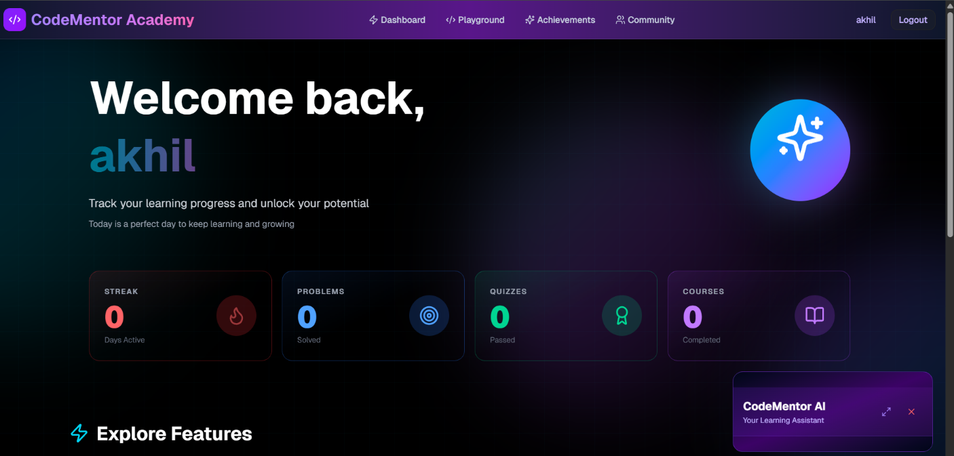
Figure 7: Main Dashboard – Roadmaps, streak counter, badges, and progress chart
11.2 Roadmap Learning Page
The learning page for a single day is divided into three visible sections. The left panel shows the theory content — AI-generated explanation of the day's concept, formatted with headings and bullet points for readability. The centre panel contains the CodeMirror code editor with the starter code pre-loaded, a Run Code button, and the output panel below it. The right panel holds the 15 quiz questions with radio-button answer choices and a Submit Quiz button at the bottom. A step indicator at the top shows which of the three sections has been completed.

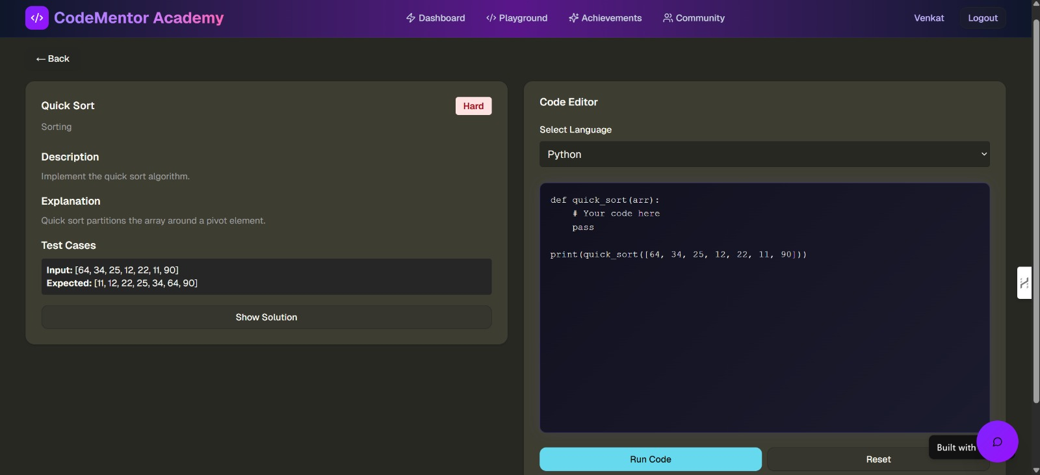
Figure 8: Daily Learning Page – Theory panel, CodeMirror editor, and quiz panel
11.3 Quiz Interface
After the user clicks Submit Quiz, a results screen appears showing the score as a percentage and a breakdown of correct and incorrect answers. For each incorrect answer, the correct answer is highlighted in green. A progress bar at the top shows how far along the user is in the current roadmap. If the score is below 60%, a message explains that the user needs to review the material and a Retry Quiz button appears. If the score is 60% or above, a success banner appears with a Next Day button.

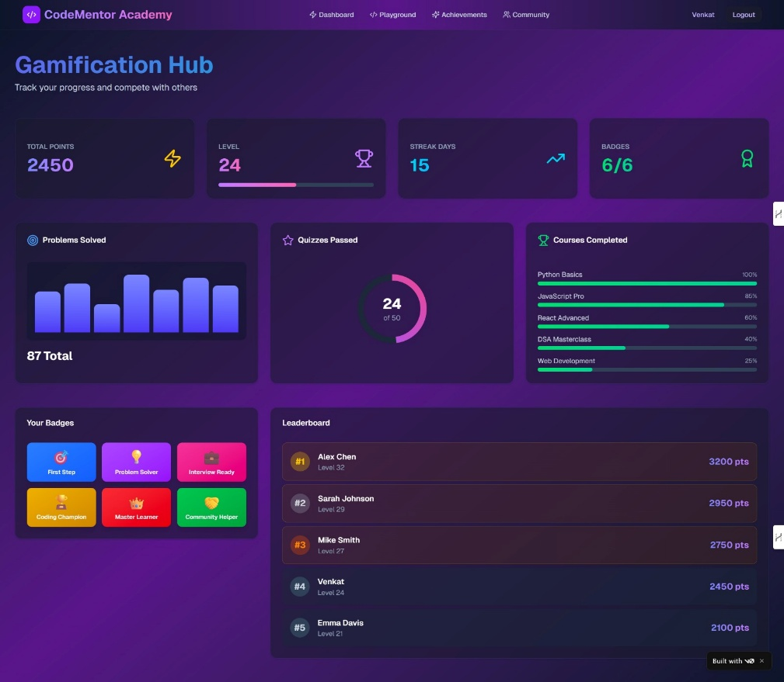
Figure 9: Quiz Interface – Score display, correct/incorrect breakdown, and progression message
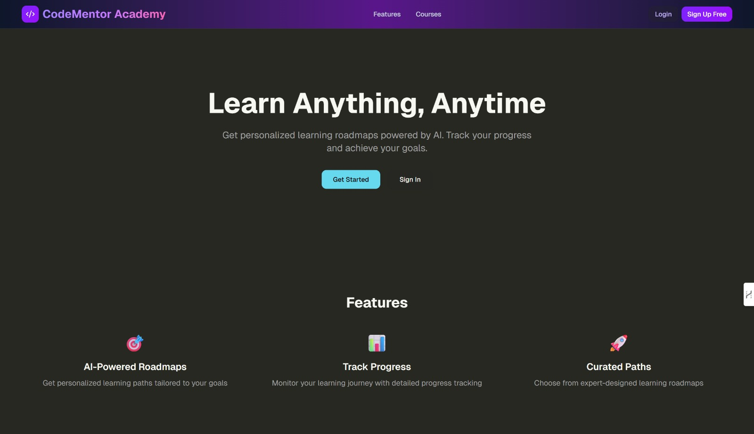
Figure 10: Landing Page

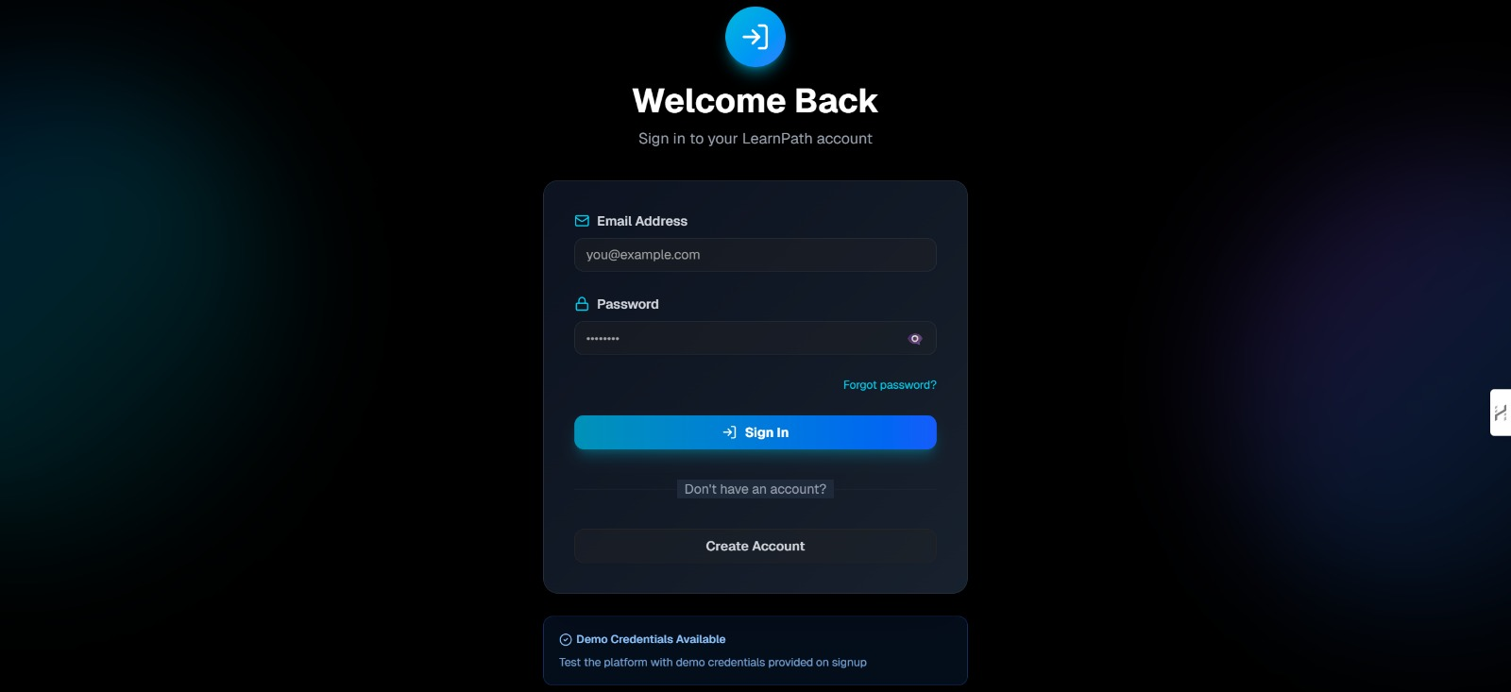
Figure 11: Login Page

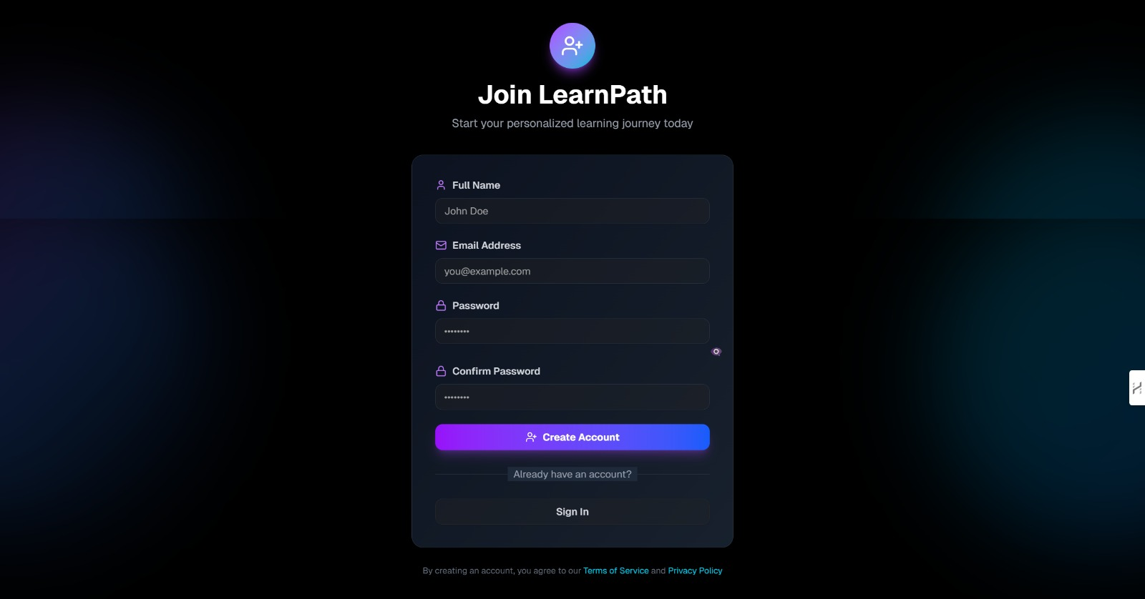
Figure 12: Signup Page

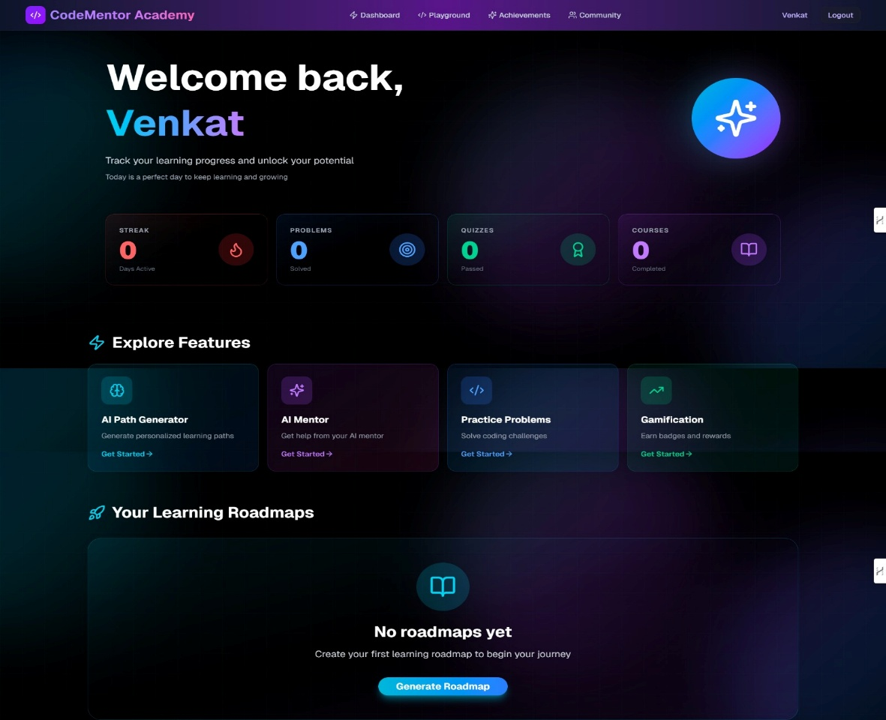
Figure 13: Dashboard

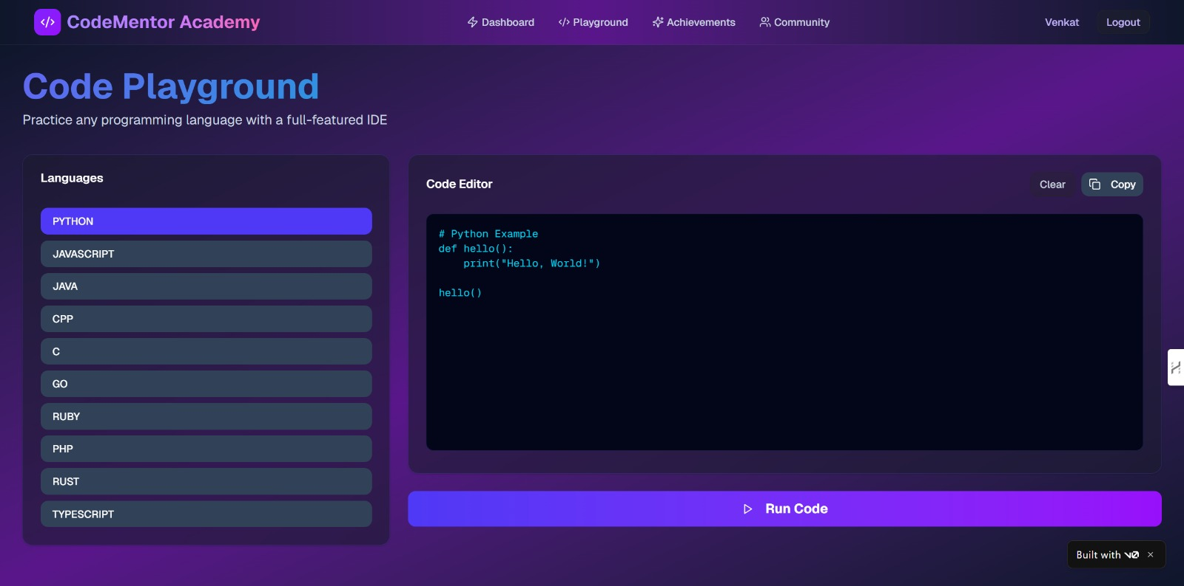
Figure 14: Code Playground For Practice

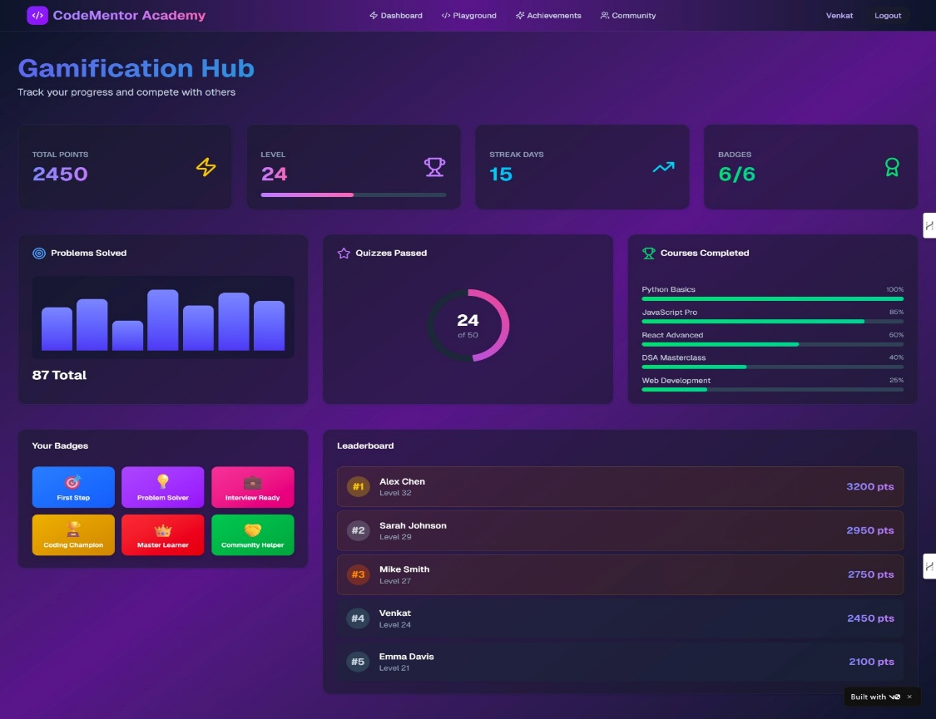
Figure 15: Gamification Hub

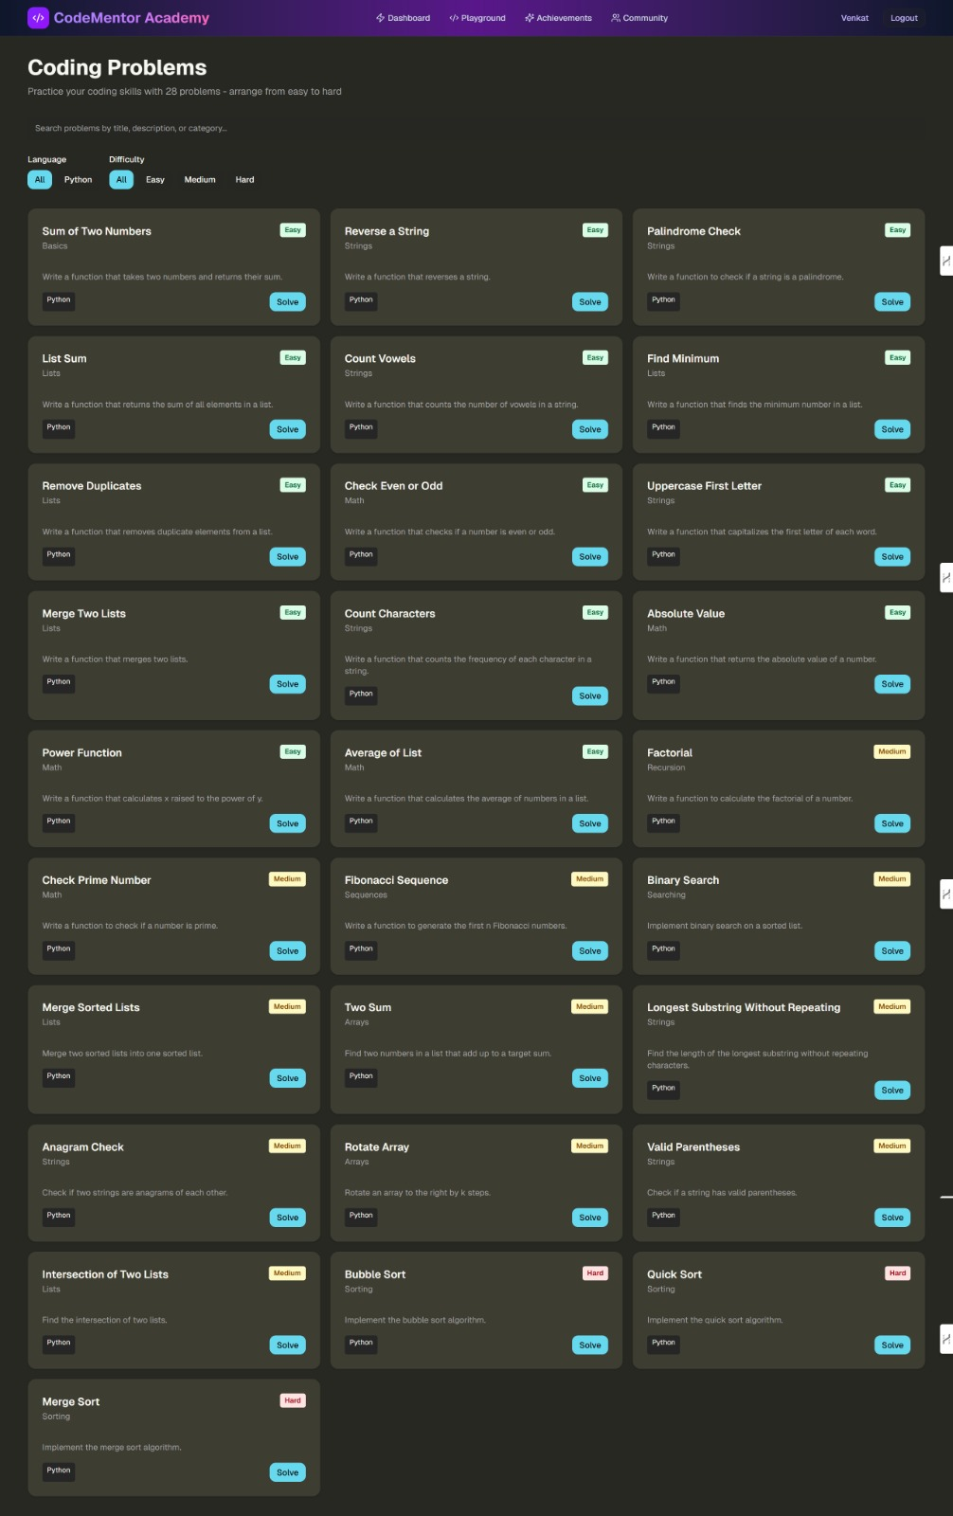
Figure 15: Coding Problems For Practice

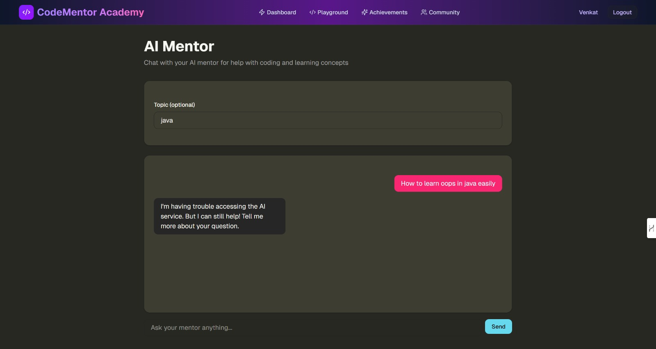
Figure 16: AI Mentor Chat Panel – Conversation with contextual roadmap awareness

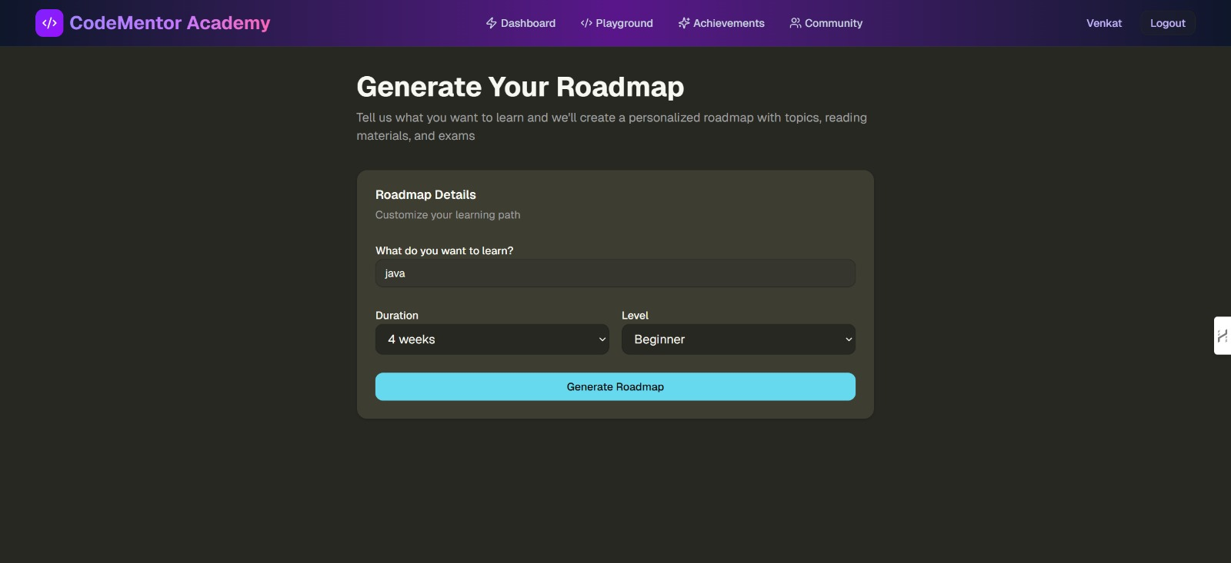
Figure 17: Generate RoadMap

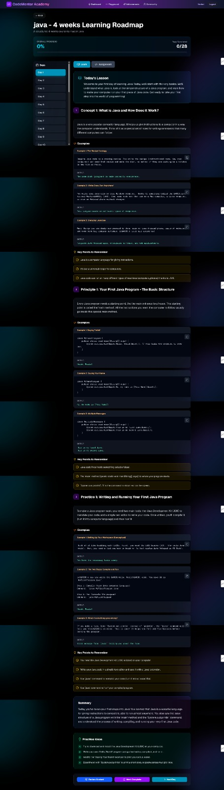
Figure 18: Detailed RoadMap

11.4 AI Mentor Chatbot
The AI mentor is a slide-out chat panel that appears from the right side of the screen. It shows the conversation history in a standard chat bubble format — user messages on the right in blue, AI responses on the left in grey. A text input at the bottom allows the user to type questions. A small context indicator at the top of the panel shows the current topic and day number so the user knows the AI is aware of their learning context. The panel can be opened and closed without losing the visible conversation history for that session.
12. References
[1] R. Sajja, Y. Sermet, M. Cikmaz, D. Cwiertny, and I. Demir, "Intelligent assistant using artificial intelligence in personalized and adaptive learning in higher education," arXiv preprint arXiv:2309.10892, Sep. 2023.

[2] I. Gligorea, M. Cioca, R. Oancea, A.-T. Gorski, H. Gorski, and P. Tudorache, "Adaptive learning using artificial intelligence in e-learning: A literature review," Education Sciences, vol. 13, no. 12, 2023.

[3] S. Bennani, A. Maalel, and H. Ben Ghezala, "Adaptive gamification in e-learning: A literature review and future challenges," Computer Applications in Engineering Education, vol. 29, no. 2, 2021.

[4] H. Hariyanto, F. X. D. Kristianingsih, and R. Maharani, "Artificial intelligence in adaptive education: a systematic review of strategies of personalized learning," Discover Education, 2025.

[5] T. Kabudi, I. Pappas, and D. Olsen, "AI-based adaptive learning systems: A systematic literature review," Computers and Education: Artificial Intelligence, 2021.

[6] S. Deterding, D. Dixon, R. Khaled, and L. Nacke, "From game design to gamefulness: Defining gamification," in Proc. 15th Int. Academic MindTrek Conference, 2011, pp. 9–15.

[7] R. M. Ryan and E. L. Deci, "Self-determination theory and the facilitation of intrinsic motivation," American Psychologist, vol. 55, no. 1, pp. 68–78, 2000.

[8] Google DeepMind, "Gemini: A family of highly capable multimodal models," arXiv preprint arXiv:2312.11805, 2023.

[9] Vercel, "Next.js 15 App Router Documentation," 2024. [Online]. Available: https://nextjs.org/docs

[10] MongoDB Inc., "MongoDB Atlas Documentation," 2024. [Online]. Available: https://www.mongodb.com/docs/atlas/

[11] CodeMirror Project, "CodeMirror 6 Reference Manual," 2024. [Online]. Available: https://codemirror.net/docs/

[12] MDN Web Docs, "JavaScript Reference," Mozilla Foundation, 2024. [Online]. Available: https://developer.mozilla.org/en-US/docs/Web/JavaScript

[13] Colby Fayock, "Getting Started with React and Next.js," freeCodeCamp, 2023. [Online]. Available: https://www.freecodecamp.org

[14] D. St-Hilaire et al., "Comparative study of learning outcomes for online learning platforms," arXiv preprint arXiv:2104.09454, Apr. 2021.

[15] W. Holmes, M. Bialik, and C. Fadel, Artificial Intelligence in Education: Promises and Implications for Teaching and Learning. Boston: Center for Curriculum Redesign, 2019.

[16] S. Pang, E. Nol, and K. Heng, "Generative AI as a language learning personal tutor: benefits and challenges," 2025.

[17] A. A. Kardan et al., "Comparison of supervised learning algorithms for student performance prediction," in Proc. Int. Conf. on Educational Technology, 2015.

[18] R. Thakur, D. Khandelwal, and S. Tiwari, "AnveshanaAI: An adaptive AI/ML learning system based on automated question generation," arXiv preprint arXiv:2509.01066, Sep. 2025.

[19] Recharts Team, "Recharts – A composable charting library for React," 2024. [Online]. Available: https://recharts.org/en-US/

[20] Tailwind CSS Documentation, "Tailwind CSS v4 Utility Classes Reference," 2024. [Online]. Available: https://tailwindcss.com/docs

